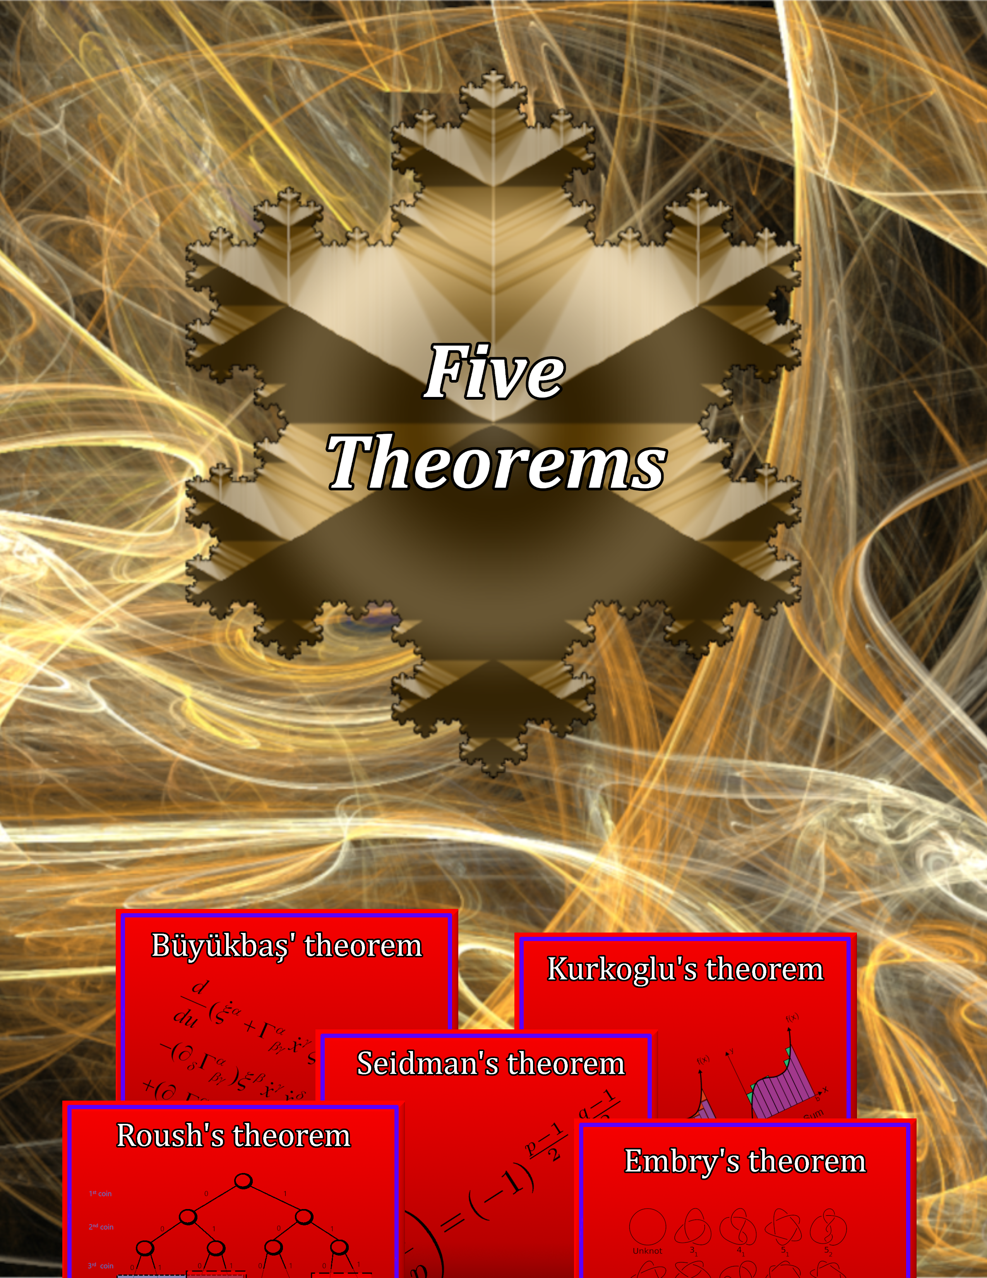

A Josh Seidman Productions game
Five theorems
Instructions
Introduction:
Welcome to Seidman University! You are so very close to finishing your Mathematics PhD but one last challenge lies ahead: prove the five unproven theorems proposed here at Seidman University. Doing so will involve arithmetic, teamwork, and problem solving.
Work with your cohort to prove the five theorems. You will need to work quickly because time is not on your side!
Important notes:
Unless otherwise specified, assist and bonus cards only apply to the player who played them.
If the instructions of a card say “number” you can use a number card, or a number obtained through arithmetic. If you are only allowed to use a number card, the instructions will say “number card” instead of just number.
Goal: To prove the 5 theorems
To prove a theorem, you need to prove its 2 lemmas first (see the theorem card for its lemmas). Once a theorem is proven it and its lemmas cannot be unproven.
To prove a lemma, you must play the lemma during the pre-puzzle solving phase, then subsequently pass the puzzle phase. If you do not pass the puzzle phase, discard the lemma.
Set-up:
- Lay out all 5 theorem cards separately
- Sort the cards into their 3 piles (green, goal, and curse)
- Deal each player 10 green cards
Pre-puzzle phase: Each player may play up to 1 lemma/bonus card from their hand during the pre-puzzle solving phase. As a team, you can play as many lemma cards as you would like but you need to pass the round multiple times to prove each lemma card.
For example: If you are playing with 3 people, you need 13 points to pass the round, which means you would need 26 points to prove both lemmas. If you accumulate 20 points, you will prove one of the lemmas (of your choice) but not the other.
Puzzle phase: A goal card is drawn from the deck. That is the goal of the puzzle phase. Then players will have a certain amount of time to use their cards to get as close to the goal number as possible. (You may change the time depending on the skill level of the players. The table below is just a suggestion for starters).
Rules for solving the puzzle:
- You may use any of the 5 arithmetic operations (+, -, * , /, ^)
- You may only use each number card once unless otherwise allowed to by a different card
- If you play a card that requires the use of other number cards, you cannot use them again during the puzzle phase (The Algebraist)
Point scoring (see the table below for timing and scoring ranges):
Level | Time | Perfect | Good | Ok | Poor
Easy | 90 seconds | Exact | Within 2 | Within 4 | More than 4
Medium | 60 seconds | Exact | Within 1 | Within 2 | More than 2
Hard | 30 seconds | Exact | Within 1/2 | Within 1 | More than 1

- If a player’s solution is perfect (exactly the goal card): 10 points
- If a player’s solution is good (within 2/1/½ of the goal card): 6 points
- If a player’s solution is ok (within 4/2/1 of the goal card): 2 point
- If a player’s solution is poor (more than 4/2/1 from the goal card): 0 points
Points required to pass the puzzle phase: 5*(# players) – 2
1 player | 3 points | 4 players | 18 points
2 players | 8 points | 5 players | 23 points
3 players | 13 points | 6 players | 28 points

For example: 2 players are playing, Player A got 6 points, and Player B got 2 points, their total would be 8 points and they would pass the puzzle round.
Post-puzzle phase: The players will have either passed the puzzle phase or not passed the puzzle phase. Points do not carry over into the next round.
If the players pass the puzzle phase, they successfully prove a lemma that was played during the pre-puzzle solving phase. If no lemma card was played then do nothing.
If the players do not pass the puzzle phase, they must draw a curse card.
Afterwards, discard all played green cards during both the pre-puzzle phase and puzzle phase. These will be shuffled back into the deck if the green cards run out. Finally, each player should draw enough green cards to get back to 10 in their hand.
Losing the game: The players can lose the game 3 ways.
- If the players get “caught cheating” twice (playing The Cheater card and subsequently drawing The Professor card after the puzzle phase), they are EXPELLED from Seidman University and instantly lose the game.
- All the curse cards are drawn. Once the last curse card is drawn the players have one last chance to win the game. If they do not win in that next turn the game is over.
- All of the goal cards are drawn. If the last goal card is drawn, finish the round and if the players have not won by the end of the puzzle phase then the game is over.
Winning the game: The players can win by proving 4 out of the 5 theorems. Players wishing to challenge themselves can attempt to prove all 5.

Materials and card clarifications
The proof cards (5 total):
- Seidman’s theorem
  - Needs two number theory lemmas to prove
- Roush’s theorem
  - Needs an analysis lemma and a probability lemma to prove
- Kurkoglu’s theorem:
  - Needs an analysis lemma and a topology lemma to prove
- Büyükbaş’ theorem:
  - Needs a geometry lemma and a probability lemma to prove
- Embry’s theorem:
  - Needs a topology lemma and geometry lemma to prove
Goal cards (50 total):
- Important constants: $π ≈3.14$, $τ≈6.28$, e $≈2.72$, $φ≈1.62$, $\sqrt{2}≈1.41$, 0
- Factorial numbers: 1, 2, 6, 24
- Primes between 1 and 100: 3, 5, 7, 11, 13, 17, 19, 23, 29, 31, 37, 41, 43, 47, 53, 59, 61, 67, 71, 73, 79, 83, 89, 97
- Other fun numbers: 4, 8, 16, 32, 64, 9, 27, 81, 69, 45, 55, 66, 78, 91,12, 25
Green cards (175 total):
Lemma cards (15 total):
- Number theory (x3)
- Analysis (x3)
- Probability (x3)
- Geometry (x3)
- Topology (x3)
Number cards (120 total):
- Every integer from 0 to 50 (x2)
- Fractions 1/$n$ where $n$ ranges from 2 to 10 (x2)
Assist cards (16 total):
- Infinite geometric series (x2): Apply any number to infinite geometric series formula $(\frac{1}{1-\#})$ to get new number (only fractions/numbers between 0 and 1 may be used with this card).
For example: If you have cards 1/2, 2, and 3. You could either use 1/2 and apply the card $\frac{1}{1-\frac{1}{2}}$ or first take 2 divided by 3 = 2/3, then apply the card $\frac{1}{1-\frac{2}{3}}$
- The square(x4): Square one number $(\#^{2})$ card in your hand.
- The triangle(x4): Convert any integer number into its triangle number $(\frac{\#\left(\#+1\right)}{2})$.
- Quotient map (x2): Change one number card in your hand into another number in your hand.
For example: You have cards 17 and 21 in your hand and am trying to obtain the number 42, you can use quotient map to change 17 into 21 then add 21 + 21 = 42.
- Seems to work (x2): Use as a wild card for any integer between 0 and 20.
For example: You have cards 13 and 22 in my hand and are trying to obtain the number 19, you can add 13 + 22 = 35, then use the Seems to work card as a 16. 35 – 16 = 19.
- Koch snowflake (x2): Use as a personal goal card of 4/3.
For example: You have cards 3 and 4 and the goal is 53. You can’t solve the puzzle of obtaining 53, so you divide 4/3 and obtain the Koch snowflake goal and gain 10 points for the puzzle phase).
Bonus cards (24 total):
- Office Hours (x3): A visit to office hours has enlightened you! Reduce the points needed to pass the subsequent puzzle phase by 1
For example: If there are 3 players, the number of points required to pass a round is 13. After playing the Office Hours card, the next puzzle phase only requires 11 points.
- A second option (x3): Draw a second goal card to choose from for the puzzle phase. The players will all vote on which one they would prefer. If there is a tie, the smaller number will be the goal card.
For example: The 2 goal cards drawn are 1/5 and 34. If there is a tie, 1/5 will be the goal card because it’s smaller.
- Math is easy (x6): You just aced a test and math is easy! Remove one Math is hard card if in play. If no Math is hard cards are in play then do nothing.
- Expanding your skillset (x2): You attended a conference on representation theory of p-adic groups and understand more math than you did beforehand. Everyone may play an additional bonus card
For example: If you play Expanding your skillset, everyone will be able to play 2 bonus cards instead of 1. Since you have already played Expanding your skillset, you may play 1 more bonus card.
- The Cheater (x2) : You have had a convenient epiphany! The next lemma played will be proved for free, but you must draw an extra curse card after the puzzle solving phase (regardless of passing the puzzle phase or not).
For example: You play The Cheater and someone else plays a lemma card. It is immediately proven then you play the puzzle phase. If you pass the puzzle phase you must draw 1 curse card. If you fail the puzzle phase, you must draw 2 curse cards (1 for failing the puzzle round + 1 for playing The Cheater).
- The Combinatorialist (x1): Take factorial of any number in their hand.
For example: If you have cards 3 and 7 in your hand, you may either use the number 3! = 6 instead of 3, or do 7 – 3 = 4 then use 4! = 24 instead of 4.
- The Student (x1): Your teacher has granted you an extension! Add 30 seconds to the timer the puzzle phase (for everyone).
For example: The puzzle phase is 90 seconds. When The Student is played, everyone has 120 seconds to come up with a solution to the puzzle instead of 90 seconds.
- The Tutor (x1): Whoever plays this card may help anyone during the puzzle phase.
- The Statistician (x1): Take the average of any 2 final puzzle solutions and replace any solution with the average of the 2.
For example: The goal card is 7. Player A got 6, Player B got 8, and Player C got 1. The Statistician may take the average of A and B (which is 7) and replace C. C’s final score is now 7 instead of 1. Players A and B’s scores are still 6 and 8 respectively.
- The Cryptographer (x1): Use each of their own prime numbers up to 3 times during the puzzle solving phase
- The Engineer (x1): Any player may round their final puzzle solution up or down to the nearest integers.
For example: The goal card is 3. You get a solution of 2.3, and another player gets a solution of 4.4. You may round your solution up to 3, and the other player may round their solution down to 4, so you get 10 points instead of 2, and the other player gets 2 points instead of 0.
- The Topologist (x1): Deform 1 number card in your hand to a homotopy equivalent one.
For example: The homotopy classes of the Arabic numerals under this font are {0, 4, 6, 9}, {1, 2, 3, 5, 7}, {8}. So, you could change 19 to 50 because 1 and 5 are in the same class and 9 and 0 are in the same class. Another example would be changing 6 to 4 because 6 and 4 are in the same class.
- The Algebraist (x1): Must be played with 1 integer number card. All numbers may be swapped for another representative of its equivalence class in ℤ/(#ℤ).
For example: You play The Algebraist with the number card 7 during the pre-puzzle phase, then you can play card 20 but use its value as 6 because [6] = [13] = [20] = … This works for fractions too, i.e. [1/3] = [7 1/3] = [14 1/3] = …
A note about equivalence classes: Two numbers are in the same equivalence class in ℤ/(#ℤ) if they are separated by a multiple of #. In ℤ/(7ℤ) 6 and 20 are in the same equivalence class because 20 = 6 + 2*7. Or 1 and 71 are in the same equivalence class because 71 = 1 + 10*7.
Curse cards (10 total):
- The Counterexample (x2): Your last lemma was flawed! Discard a lemma from an unproved theorem back into the pile. If this card does not apply (there are no lemmas proven or every lemma proven is a part of a proven theorem), then do nothing.
- Math is hard (x4): You just failed a math test! Until this card is removed (by playing a Math is easy card), the points required to pass every puzzle round has been increased by 2.
- The Professor (x4): If this card is drawn after playing The Cheater card, discard 2 proven lemmas (unless the lemmas are a part of a proven theorem)
For example: The Cheater card is played during the pre-puzzle phase along with a lemma. If The Professor is drawn after the pre-puzzle phase, the players must decide on 2 lemmas to discard. If they can only discard 0 or 1 lemmas because all the other lemmas are a part of proven theorems, then do nothing. If The Professor is drawn 2 times in one round, the players must discard 4 lemmas.

Best of luck! Feel free to change the time per puzzle round, scoring ranges, and point system to whatever you feel is comfortable. This is a first draft so not everything will be fine tuned yet :)

Picture credits to: Static989 on DeviantArt, Niradenar on DeviantArt, mydarkangel on wallpapersafari, someone on teahub.io
